|  |
| --- |
|  |
| TrackMyWords – User Manual |
| Comp231-062 |
| **Taras Paniuta – 300795251**  **Amina Abbasi – 300703899**  **Navpreet Singh – 300775872**  **Luke Farnell – 300700511**  **Joanne Tanson – 300767984**  **Andrew Cumming – 300695420**  **Aakash Jain – 300795874** |
|  |
|  |

|  |
| --- |
|  |

# Search Screen

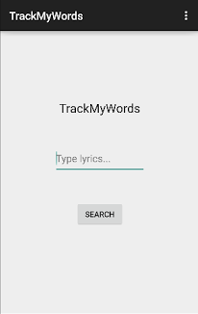

Search Screen

1

2

This is the first page of our app, TrackMyWords. On this screen, there is a spot to type in the lyrics you want to search for in our database (1). Once you type in the lyrics, the search button needs to be selected/clicked (2) in order for the app search the database for the song containing the lyrics. When a User wants to search for a song, they first press on the spot where it says “Type lyrics…”(1).

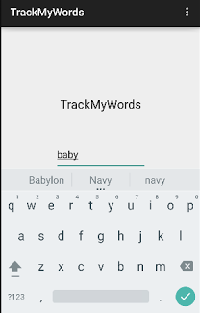

4

3

5

The “Type lyrics…” will disappear and a keyboard (3) will show up when the user wants to search for a song. The user will type in the space provided (4) and then press the checkmark (5) once they complete the lyrics.

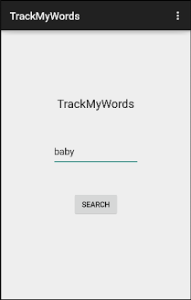

6

7

The User’s query will show up (6) and they will have to press “Search” (7) in order to execute the query.

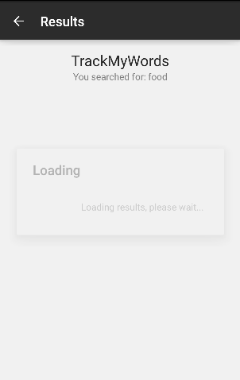

Loading Screen

Once “Searched” is selected, the Loading screen will show up looking for the queried results.

# Results Page

Figure A

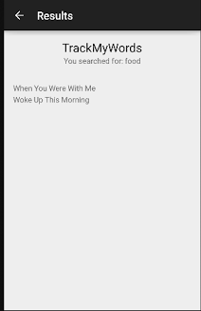

Figure B

8

If the lyrics queried are in the database, then this result page will be displayed (8). It will display all the songs that contain the lyrics the user searched for. Figure A shows the Result Page with a scroll bar. This appears when not all the songs queried can fit onto a page. Figure B shows all the songs queried that can fit onto a page and does not require a scroll bar. The User can select the song from this page and it will go to the Lyrics page, which will contain artist, album and the lyrics for that song.

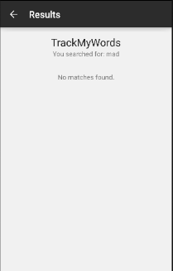

Figure C

If the User’s search did not find any songs that contained the lyrics they were looking for, a “No Matches Found” message will appear (Figure C).

# Lyrics Page

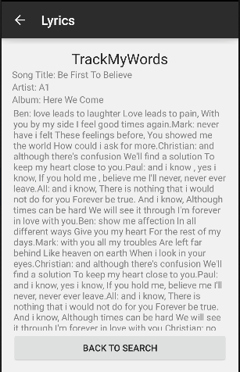

9

Figure D

Once the User selects a song, the “Lyrics” page will show up (Figure D). This page will contain the song’s title, artist, album and the lyrics for the song. Users can scroll down the page to see the rest of the lyrics. The User can also go back to the “Search Screen” by pressing the “BACK TO SEARCH” button (9).

# Admin – View Records

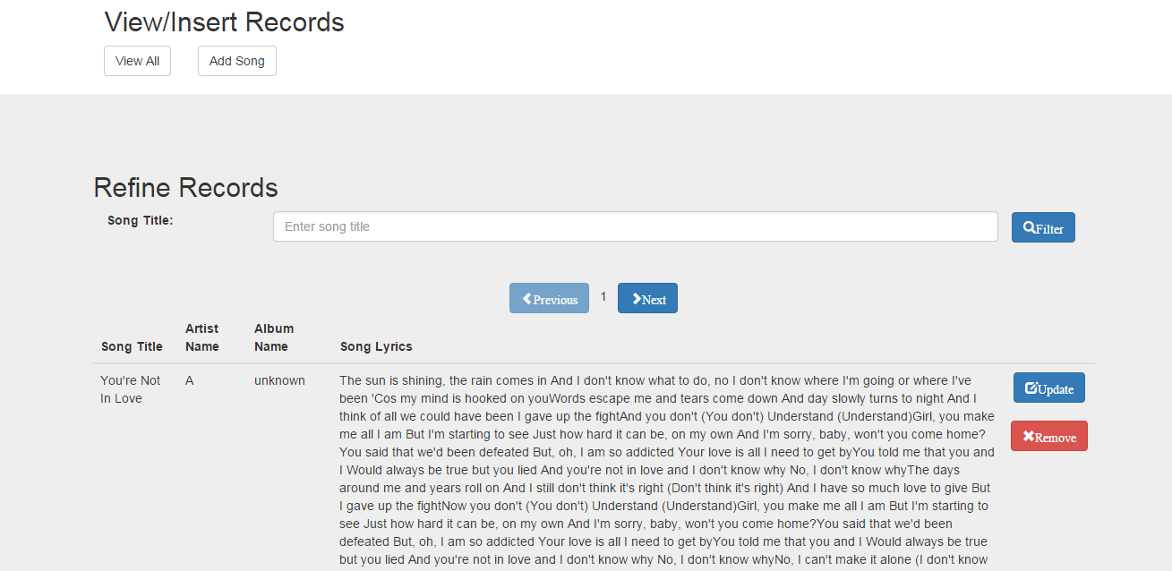

10

14

12

13

11

Figure E

The Admin has the capability to add (10), read (11), update (12) and delete songs (13), as shown in Figure E. When the admin is on website, they can see the first 25 songs in the database, are able to see more by going to the next page. They also can search for a song (14).

# Search Song

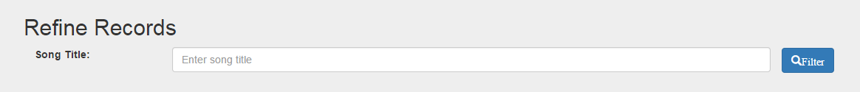

Figure F

The Admin can search for a song by entering its “Song Title” into the search bar and then clicking on “Filter”. This feature will sort through all the songs in the database that contains those words in the title and display it in the view below (Figure G). The Admin also can Update the song record or remove it from the database. When the Admin clicks on “Update Song”, it will take them to a new page where they can edit.

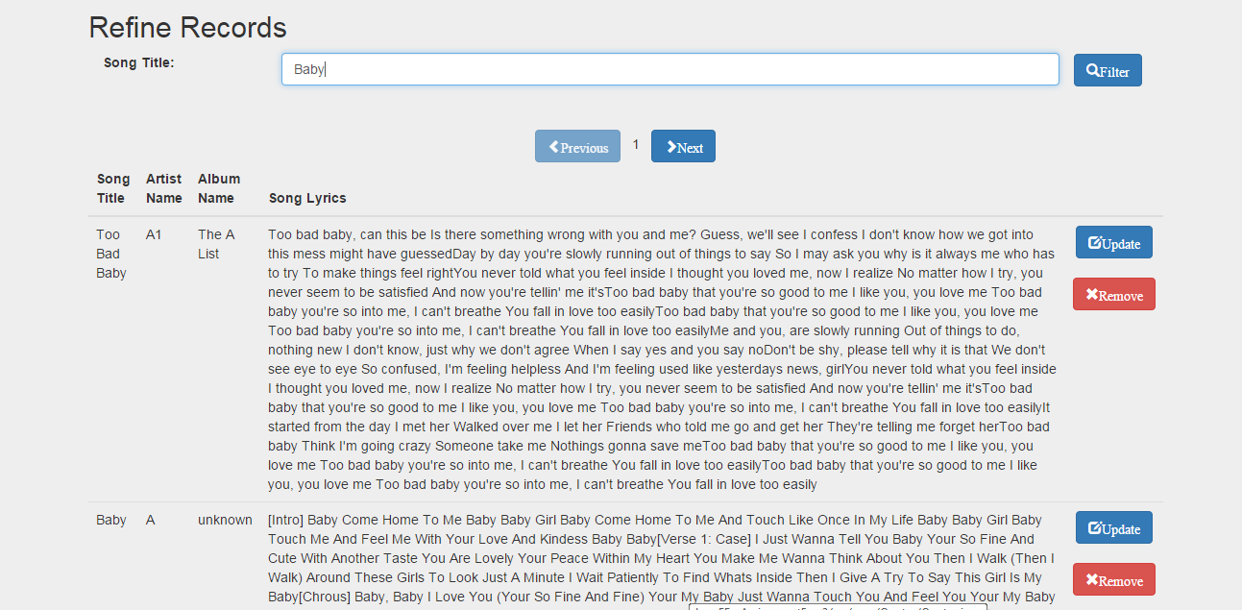

Figure G

# Update

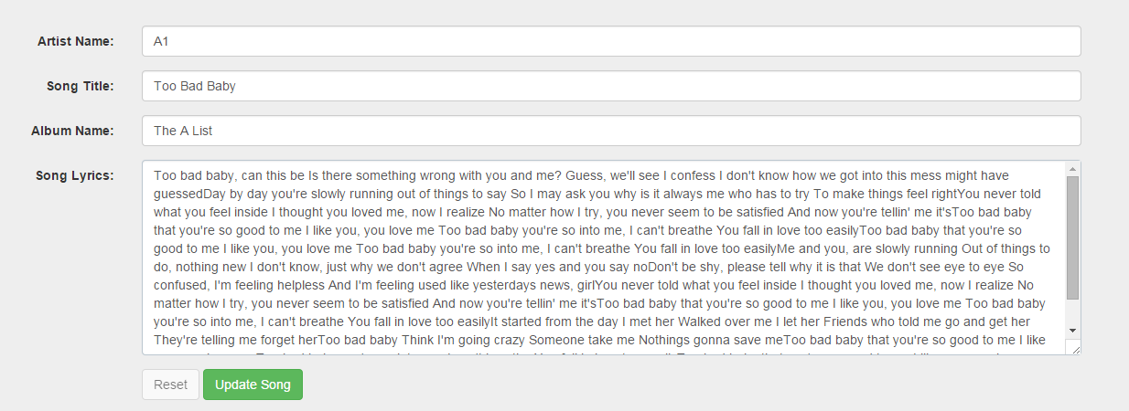

Figure H

The Admin can update a song record after clicking on “Update Song”. The form is already filled out for them and the Admin can change/update what is needed (Figure H). Once completed, they can click the “Update Song” button to save changes.

# Add Song

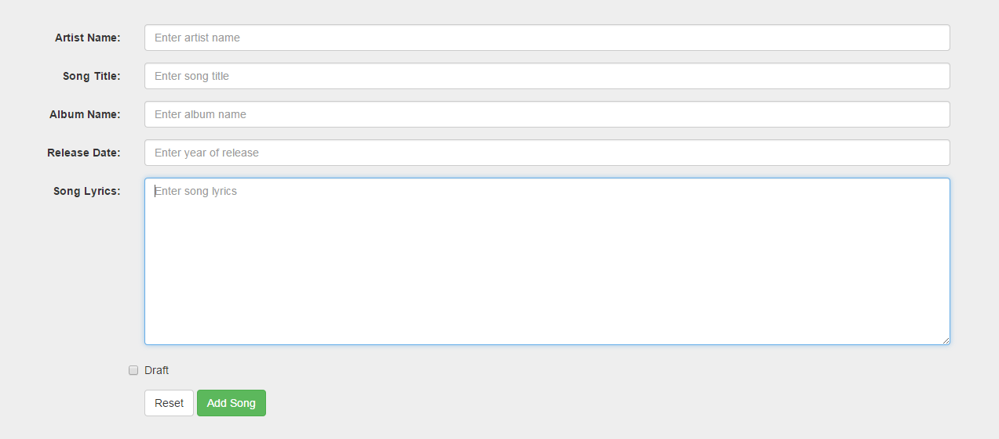

Figure I

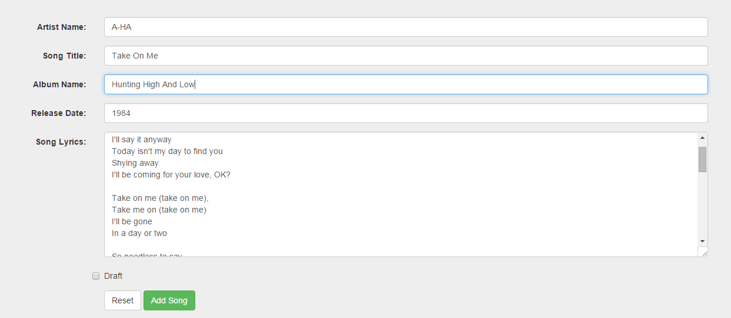

Figure J

When the Admin selects “Add Song”, a new page opens for the Admin with a blank form (Figure I). Here, the admin can fill out the record (Artist Name, Song Title, Album Name, Release Date and Song Lyrics) and then save it to the database by clicking on Add Song (Figure J). The Admin also has a choice of putting the record into draft mode. This will save the record, but will not be published for public viewing. The Admin can also “Reset” the form and start all over again as well.